DANCİNG :

Q1: What does the 3-letter acronym SMB stand for?
A1: Server Message Block

Q2: What port does SMB use to operate at?
A2: 445

Q3: What is the service name for port 445 that came up in our Nmap scan?
A3: microsoft-ds
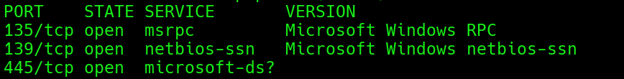

Q4: What is the 'flag' or 'switch' that we can use with the smbclient utility to 'list' the available SMB shares on Dancing?
A4: -L
(List)

Q5: How many shares are there on Dancing?
A5: 4
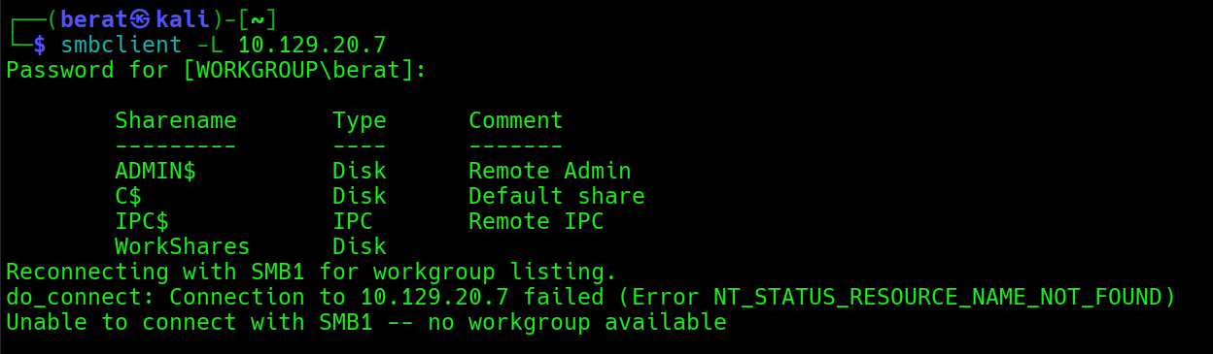

Q6: What is the name of the share we are able to access in the end with a blank password?
A6: WorkShares

Q7: What is the command we can use within the SMB shell to download the files we find?
A7: get

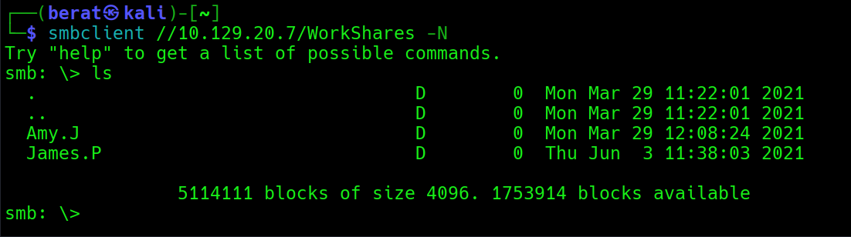

Q8: (Flag) :
A8: 5f61c10dffbc77a704d76016a22f1664

